**For Immediate Release:** **May 2025**

**DC10 FT Aluminum Top Bulkhead Set**

Factory Team is delighted to introduce the DC10 FT aluminum top bulkhead set! These items are a direct replacement for the DC10 plastic top bulkhead and will eliminate the use of the two outer posts. Both items are enriched with post operation chamfers that customers have come to love from Factory Team. Have that luxurious machined silver shine bright and signal to everyone you demand quality and nothing less.

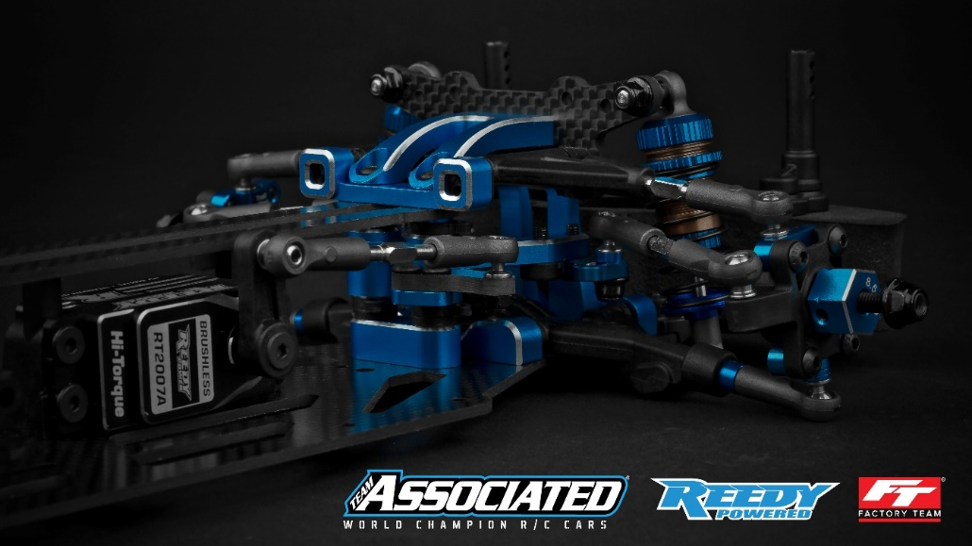

|  |  |  |  |  |  |  |
| --- | --- | --- | --- | --- | --- | --- |
| **UPC** | **Part No.** | **Description** | **MAP** | **MSRP** | **Origin** | **Available** |
| 784695722620 | 72262 | DC10 FT Aluminum Top Bulkhead Set | $24.64 | $28.99 | CN | Now |

