For Immediate Release: January 2026

RC10B7.1D Kit #90047
1:10 Scale 2WD Electric Off Road Competition Buggy Kit

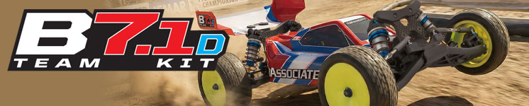

ELECTRIC ■ OFF ROAD ■ 1:10 SCALE ■ 2 WHEEL DRIVE ■ KIT
The Team Associated RC10B7.1D is Engineered for Victory!

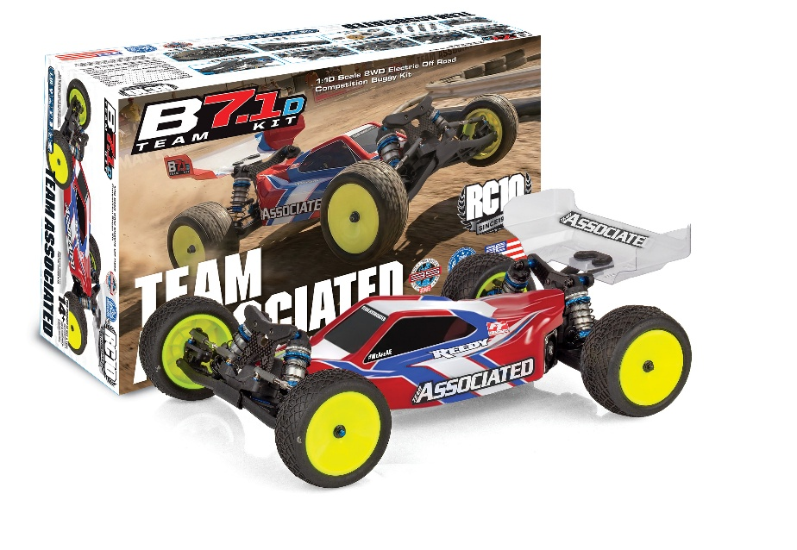

Team Associated has been at the leading edge of 1:10 scale 2WD off road for over 40 years, starting with the original RC10 and are proud to introduce the RC10B7.1D. 40 years has seen a lot of development and changes with each generation being a step forward from the last. The RC10B7.1D boasts the new long-arm suspension geometry, weight-centralized electronics layout, KPI adjustable steering blocks, and increased tunability throughout the whole chassis. These innovations have increased the potential for grip and corner speed which leads to faster lap times and an overall smoother drive feel.

The RC10B7.1D is the recommended starting kit for those who plan to race on dirt, clay, and some low-grip AstroTurf tracks. This kit comes equipped with a ball differential and an optimized setup which includes softer springs and lower pack pistons. As with previous generations, the RC10B7.1D and RC10B7.1 feature fully interchangeable parts between the two kits, which allows the user to pick and choose what configuration they want to use depending on track conditions. Both versions come with the same durability, speed, and lineage of a champion that is found in any Team Associated race platform.

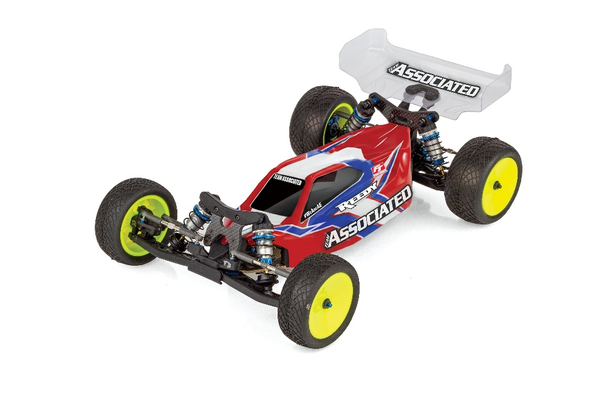

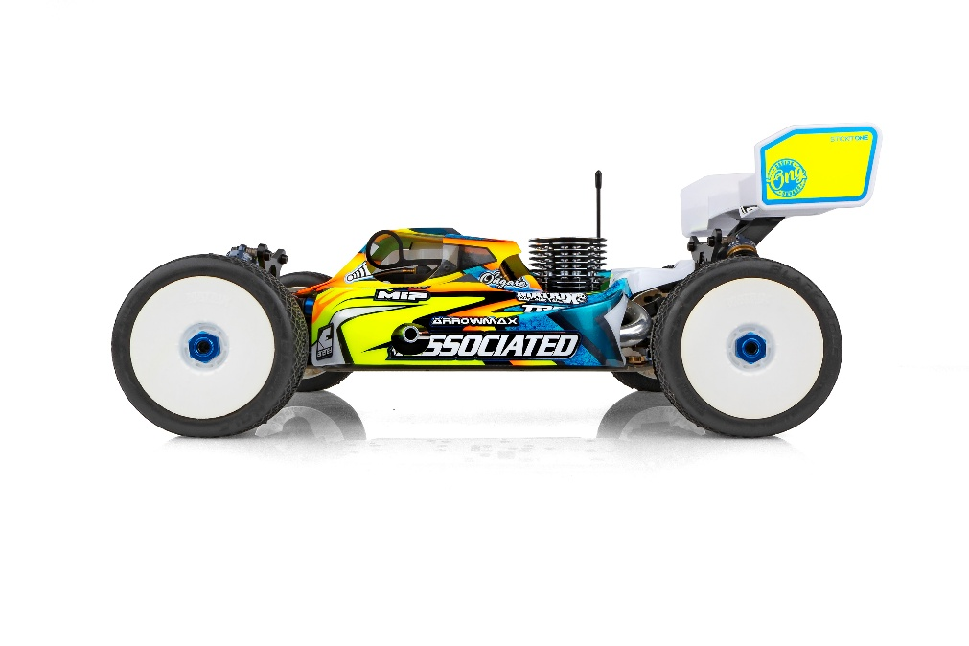

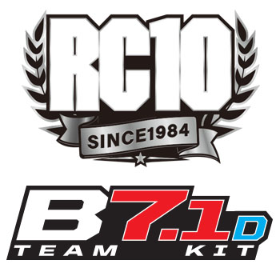
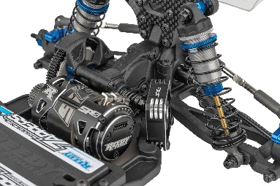
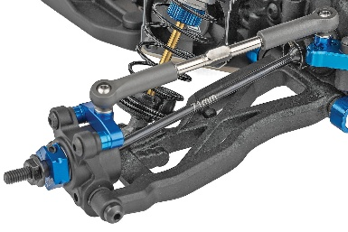

3-Gear Laydown Transmission that maintains original B7 motor position while reducing rotational weight and drag
81mm Rear Suspension Arms and 71mm CVA Bones

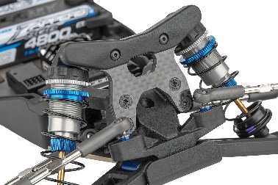
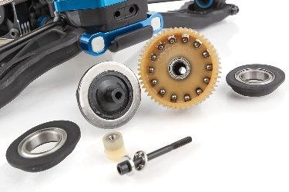
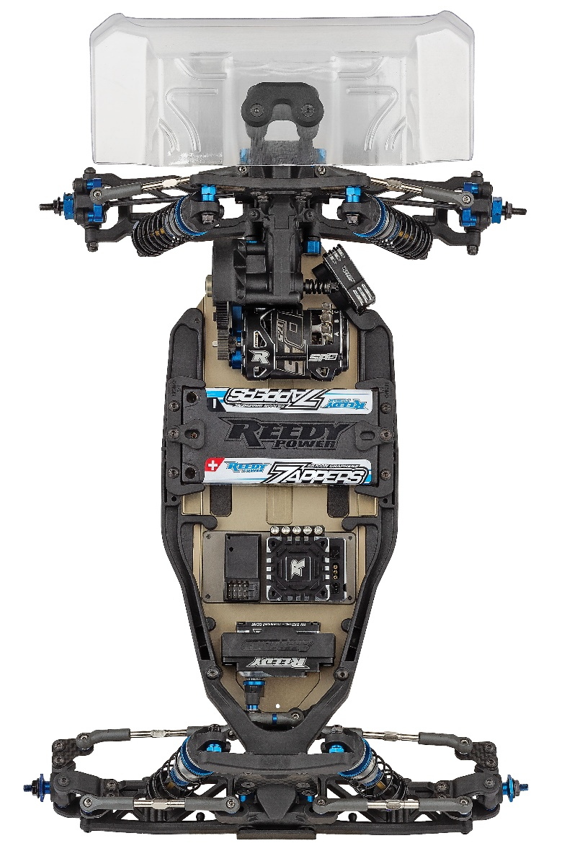

-2mm Front Shock Tower and FT -2mm Rear Shock Tower included for lower center of gravity
Ball Differential Included

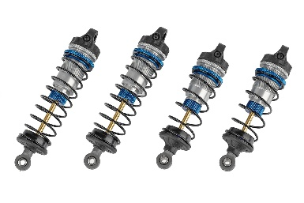
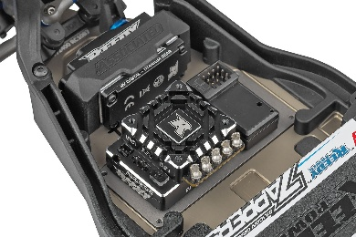

13mm Big-Bore Shocks
7075-T6 Aluminum Chassis with Optional Weight Plate Pockets (Aluminum plate included)

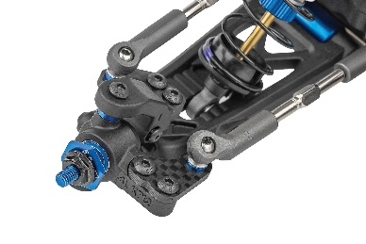
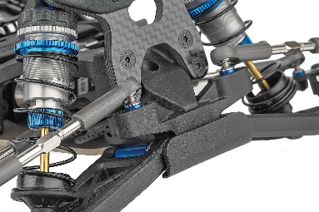

NEW -2mm Front Ballstud Mount included along with updated Top Plate and Standard Ballstud Mount
NEW Steering and Caster Block Assembly simplifies assembly and reduces weight without sacrificing tunability

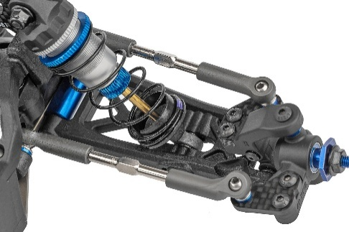
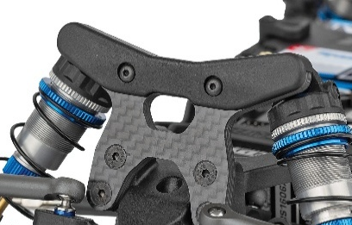

3.5mm Turnbuckles and Ballcups
Shock Tower Covers Front and Rear
Scale | 1:10
Power | Electric
Drive | 2WD
Length (w/Wing): | 390mm/15.4 in.
Width | Varies*
Weight | Varies*
Wheelbase | Varies*
Internal Gear Ratio: | 2.60:1
Type: | Off Road
Chassis: | Machined aluminum
Suspension: | Independent Front and Rear

ITEMS NEEDED TO COMPLETE

- Motor
- ESC
- Servo
- Tires
- Wheels

OTHER HELPFUL ITEMS |  |  | SPECIFICATIONS

- Silicone Shock Fluid (Refer to catalog for complete listings)
- Silicone Diff Fluid (Refer to catalog for complete listings)
- Body Scissors (AE Part # 1737)
- Reamer / Hole Punch
- FT Wrench Set (AE Part #1519)
- Hobby Knife
- Needle Nose Pliers
- Wire Cutters
- Soldering Iron
- Calipers or a Precision Ruler

- Includes 3-Gear Laydown Transmission that maintains original B7 motor position while reducing rotational weight and drag

- NEW Steering and Caster Block Assembly simplifies assembly and reduces weight without sacrificing tunability

- NEW -2mm Front Ballstud Mount included along with updated Top Plate and Standard Ballstud Mount

- NEW Front Suspension Arms with Hinge Pin Brace for improved durability

- NEW -2mm Front Shock Tower and FT -2mm Rear Shock Tower included for lower center of gravity

- Includes 81mm Rear Suspension Arms and 71mm CVA Bones

- Includes Ball Differential

- Low-Profile RC10B7 Body, 7-inch Rear Wing, and 2.5-inch Front Wing

- 7075-T6 Aluminum Chassis with Optional Weight Plate Pockets (Aluminum plate included)

- Shock Tower Covers Front and Rear

- 3.5mm Turnbuckles and Ballcups

- 13mm Big-Bore Shocks

FEATURES |  | SPECIFICATIONS
UPC | Part No. | Description | MSRP | MAP | Pieces Per Case | Origin | Available
784695900479 | 90047 | RC10B7.1D Team Kit | $589.99 | $399.99 | 6 | TW | Jan

Download all zipped photos here: https://wwww.rc10.com/RC10B71DImages/ (5.0MB). Link is active for 30 days.
Please refer to our MAP Policy here: https://img2c.associatedelectrics.com/pdf/map-policy.pdf

