For Immediate Release: October 2025

#30143 RC10 6x6 Metallic
1:10 Scale 6x6 American Custom Semitruck Kit



ELECTRIC ■ 1:10 SCALE ■ 6 WHEEL DRIVE ■ KIT
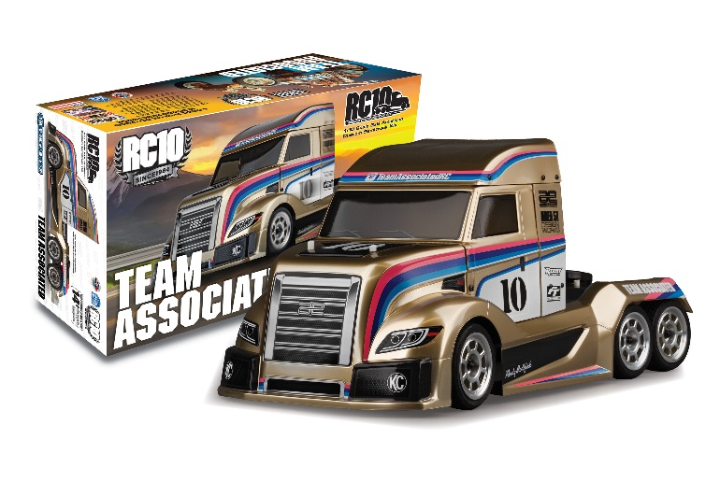
Champions by Design
We are excited to introduce the RC10 American Custom Semitruck 6x6 Metallic Kit, a groundbreaking addition to our lineup that combines innovation with high-performance design. This comprehensive kit boasts a range of exceptional features, including durable white plastic parts, a striking new 6x6 body set, and a robust 6x6 plastic gearbox set. It also includes a 6x6 diffuser set with body accessories, a sleek metallic gold aluminum chassis plate, and high-quality FT ball end set. For enhanced control and precision, the kit features aluminum turnbuckles, metallic gold shocks, and a metallic gold motor plate. Completing the package are satin chrome wheels, adding both style and functionality. Build the ultimate 6x6 vehicle with the RC10 American Custom Semitruck 6x6 Metallic Kit!!

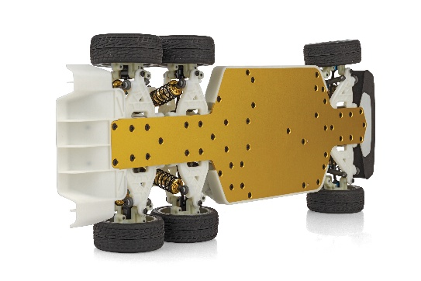

On December 5th, 1984 the all-American designed Team Associated RC10 was introduced to the RC world. Being the first to take home the gold in both the ROAR National and IFMAR 2WD World Championships, the RC10 secured its place as a legend in RC car history. 2024 marked the 60th anniversary of Associated Electrics/Team Associated, the 40th anniversary of the RC10.

It is for that reason, we are proud to offer this unique Kit, the RC10 American Custom Semitruck 6x6.

The RC10 6x6 Kit pays tribute to the legendary RC10 by incorporating the nostalgic look of the car that changed RC off-road racing forever. The customized full decal sheet features the same classic livery along with the look of natural colored plastics and gold anodized aluminum parts.
If you’re a fan of vintage RC, then the RC10 American Custom Semitruck 6x6 Kit from Associated Electrics is the vehicle for you!

A TRIBUTE TO THE CAR THAT CHANGED RC OFF-ROAD RACING FOREVER!

FEATURES
  SPECS
• White color plastic parts
• 6x6 body set
• 6x6 plastic gearbox set
• 6x6 diffuser set and body accessories
• 6x6 aluminum gold chassis plate
• Factory Team ball end set
• Aluminum turnbuckle
• Metallic gold shocks body
• Metallic gold motor plate
• Satin chrome wheel
Scale | 1:10
Power | Electric
Length | 465mm/18.3” *
Width | 190mm/7.48” *
Weight | Varies*
Wheelbase | 259-332mm/ 10.2”-13”
Transmission Ratio | 2.6:1
Drive | 6WD

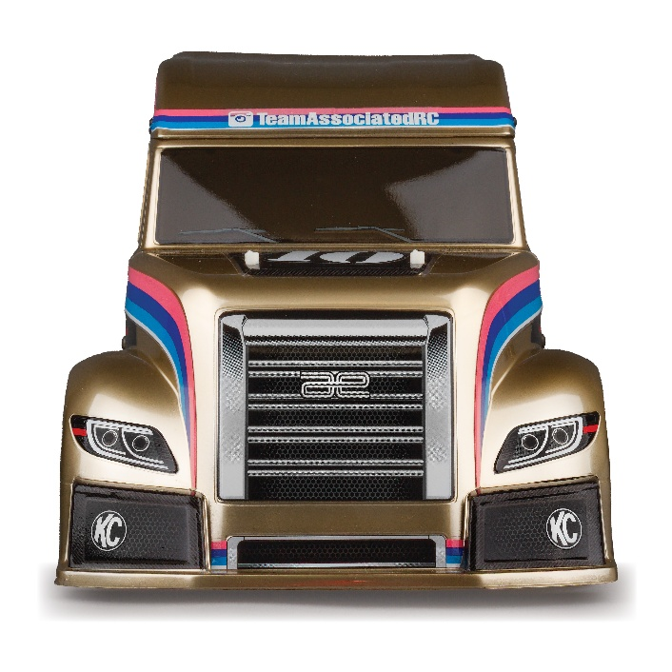

OTHER HELPFUL ITEMS
• Silicone Shock Fluid (Refer to catalog for complete listings)
• Silicone Diff Fluid (Refer to catalog for complete listings)
• Body Scissors (AE Part # 1737)
• Reamer / Hole Punch
• FT Wrench Set (AE Part #1519)
• Hobby Knife
• Needle Nose Pliers
• Wire Cutters
• Soldering Iron
• Calipers or a Precision Ruler

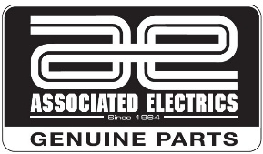
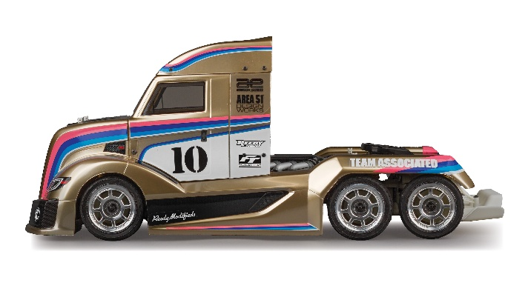

Items required for operation:
ESC, Motor, Receiver, Transmitter, Servo, suitable NiMh or 2S/3S LiPo battery for vehicle, and a charger.

CATALOG INFORMATION

UPC | Part No. | Description | MSRP | MAP | Pieces Per Case | Origin | Available
784695301436 | 30143 | RC10 6x6 Metallic  Edition Kit | $558.99 | $379.99 | 4 | TW | Now
Download all zipped photos here: https://www.rc10.com/RC106X6MetalllicImages/ (6.93 MB). Link is active for 30 days.
Please refer to our MAP Policy here: https://img2c.associatedelectrics.com/pdf/map-policy.pdf

