

For Immediate Release: November 2025

New On-Road FT parts

#1530 FT stepped ride height gauge, 3-7mm
#1531 FT chassis droop gauge support blocks, 10mm
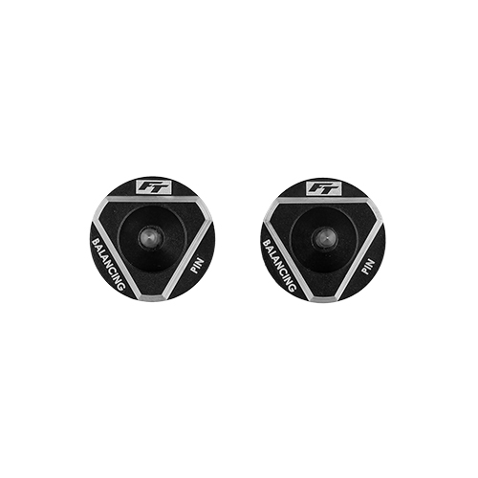
#1533 FT chassis balancing tool
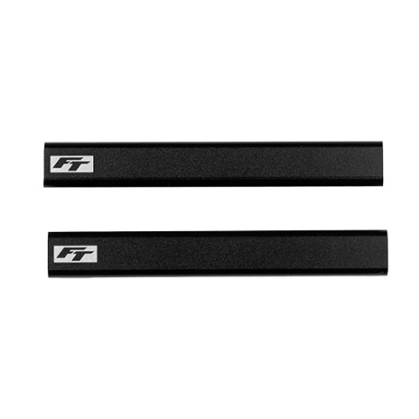
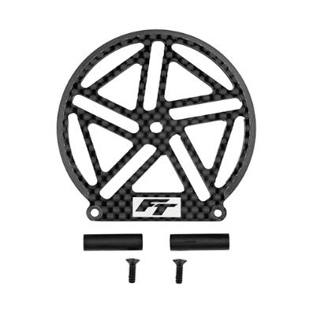
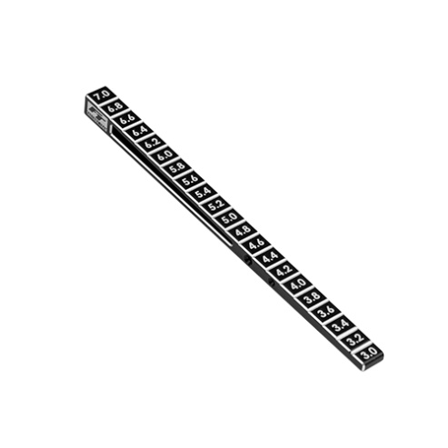
#1534 FT on-road wheel arch cutout tool

#1534

#1533

#1531

#1530

Factory Team proudly introduces new tools for on-road use! The stepped ride height gauge (#1530) allows for easy ride height adjustment readings in 0.2mm increments starting from 3mm and ending at 7mm. The 10mm droop gauge support blocks (#1531) are machined to tight tolerances to allow for very precise and repeatable droop measurements. Balancing your car can be made easy with the new chassis balancing tool (#1533). Simply rest your vehicle on the balancing tool using the two holes in the chassis (one on the front, one on the rear). Tracing out the fender well on your body can be done using the on-road wheel arch cutout tool (#1534). This item allows you to trace out the fender well and ensure it is centered with the tire.
All parts compatible with:

30141, 30142

UPC | Part No. | Description | MSRP | MAP | Origin | Available
784695015302 | 1530 | FT stepped ride height gauge, 3-7mm | $26.99 | $22.94 | TW | Now
784695015319 | 1531 | FT chassis droop gauge support blocks, 10mm | $22.99 | $19.54 | CH | Now
784695015333 | 1533 | FT chassis balancing tool | $19.99 | $16.99 | CH | Now
784695015340 | 1534 | FT on-road wheel arch cutout tool | $16.99 | $19.99 | CH | Now

Please refer to our MAP Policy here: https://img2c.associatedelectrics.com/pdf/map-policy.pdf

