For Immediate Release: June 2026

RC10T84 FT Chassis Protector #92632
Factory Team is pleased to announce the RC10T84 FT chassis protector! Add an extra layer of protection with this simple decal. Precisely cut to fit your vehicle with a very familiar graphic that lets the audience know what brand you run.

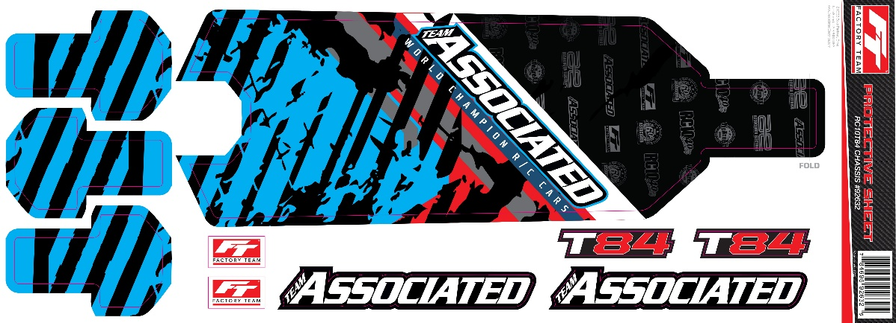

(Pictured: 92632 RC10T84 FT Chassis Protector)

Compatible with:
#90057 RC10T84 Team Kit

UPC | Part No. | Description | MAP | MSRP | Origin | Available
784695926325 | 92632 | RC10T84 FT Chassis Protector | $14.44 | $16.99 | US | 

