For Immediate Release: February 2026

RC10B6 Builder’s Support Kit 2 #90053

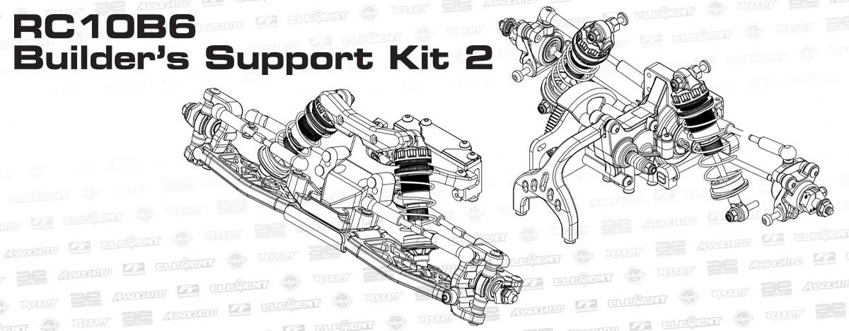

ELECTRIC ■ MULTI-SURFACE ■ 1:10 SCALE ■ 2 WHEEL DRIVE ■ KIT

Champions by Design.1:10 scale 2WD off road has been Team Associated’s signature class since the release of the RC10 in 1984. The Team Associated RC10 buggy series has won 13 of the 18 I.F.M.A.R. World Championships contested since the racing class began. In fact, Team Associated has won more 2WD I.F.M.A.R World Championships than all other manufacturers combined!

The RC10B6 Builder’s Support Kit 2 brings Team Associated race-winning technology to Builder’s assembling dirt oval sprint cars, late models, and custom drag cars. The applications are endless. The Builder’s Support Kit has the major sub-assemblies builders need in a value-packed kit, without having to pay for excess 2WD off-road buggy parts.

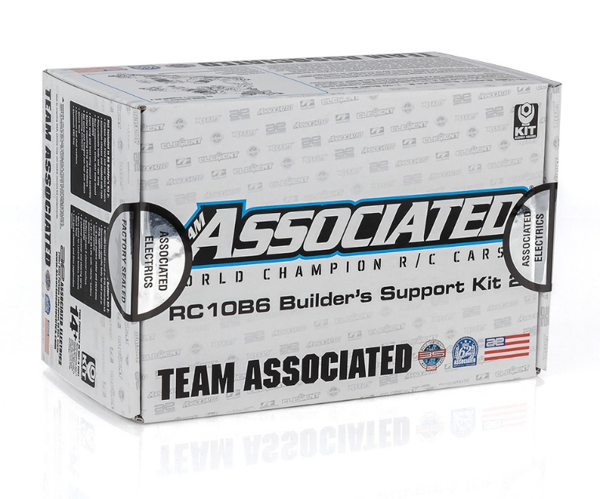

At the heart of the RC10B6 Builder’s Support Kit is the Laydown, Layback, and Standup transmissions with ball differential; all gearboxes are included. Putting the power down is the next-generation Octalock slipper clutch with Factory Team LCF slipper pads. Along with the easy-access rear differential, the rear end includes standard pivot rear blue aluminum arm mounts, 69mm CVA bones and B7 rear hubs. The kit also includes a set of four 13mm Big Bore shocks, all four with 23mm length bodies for custom build applications. Builders need only select an appropriate application, and they can bolt on the suspension, shocks, hubs, drivetrain, and gearbox from the Builder’s kit. The opportunities are endless to customize your dirt oval or drag car from any of the B6-based third-party specialty manufacturers in the industry.

FEATURES
- Updated B6.4 -1 scrub caster and steering blocks
- Wide pivot rear aluminum arm mounts for use with B6.2 series 69mm CVA bones Fiberglass shock towers
- RC10B7 rear hubs, B7 upper caps, and B6.2/B7 +2 CVA axles
- B74 rear outer hinge pins included with M3 locknuts
- 13mm diameter 2.5mm thick machined shock pistons
- Updated RC10B7 shock rod ends
- 5mm aluminum clamping wheel hexes
- B6 series Ball differential included
- Lightweight aluminum one-piece top shaft

- All 3 B6.1 series gearboxes: laydown, layback, and standup gearboxes included for tuning mass balance to different track surfaces
- Hardware included for gearboxes
- 13mm big bore threaded aluminum shocks (four 23mm bodies and four 21mm shafts) with X-rings for low friction assembly
- 13mm shock springs (orange front, red rear) for most dirt oval and on-road type applications
- Updated B6.4 front end assembly (ball stud mount, steering bellcranks, steering rack, and top plate) with gull wing front arms and blue aluminum front axles

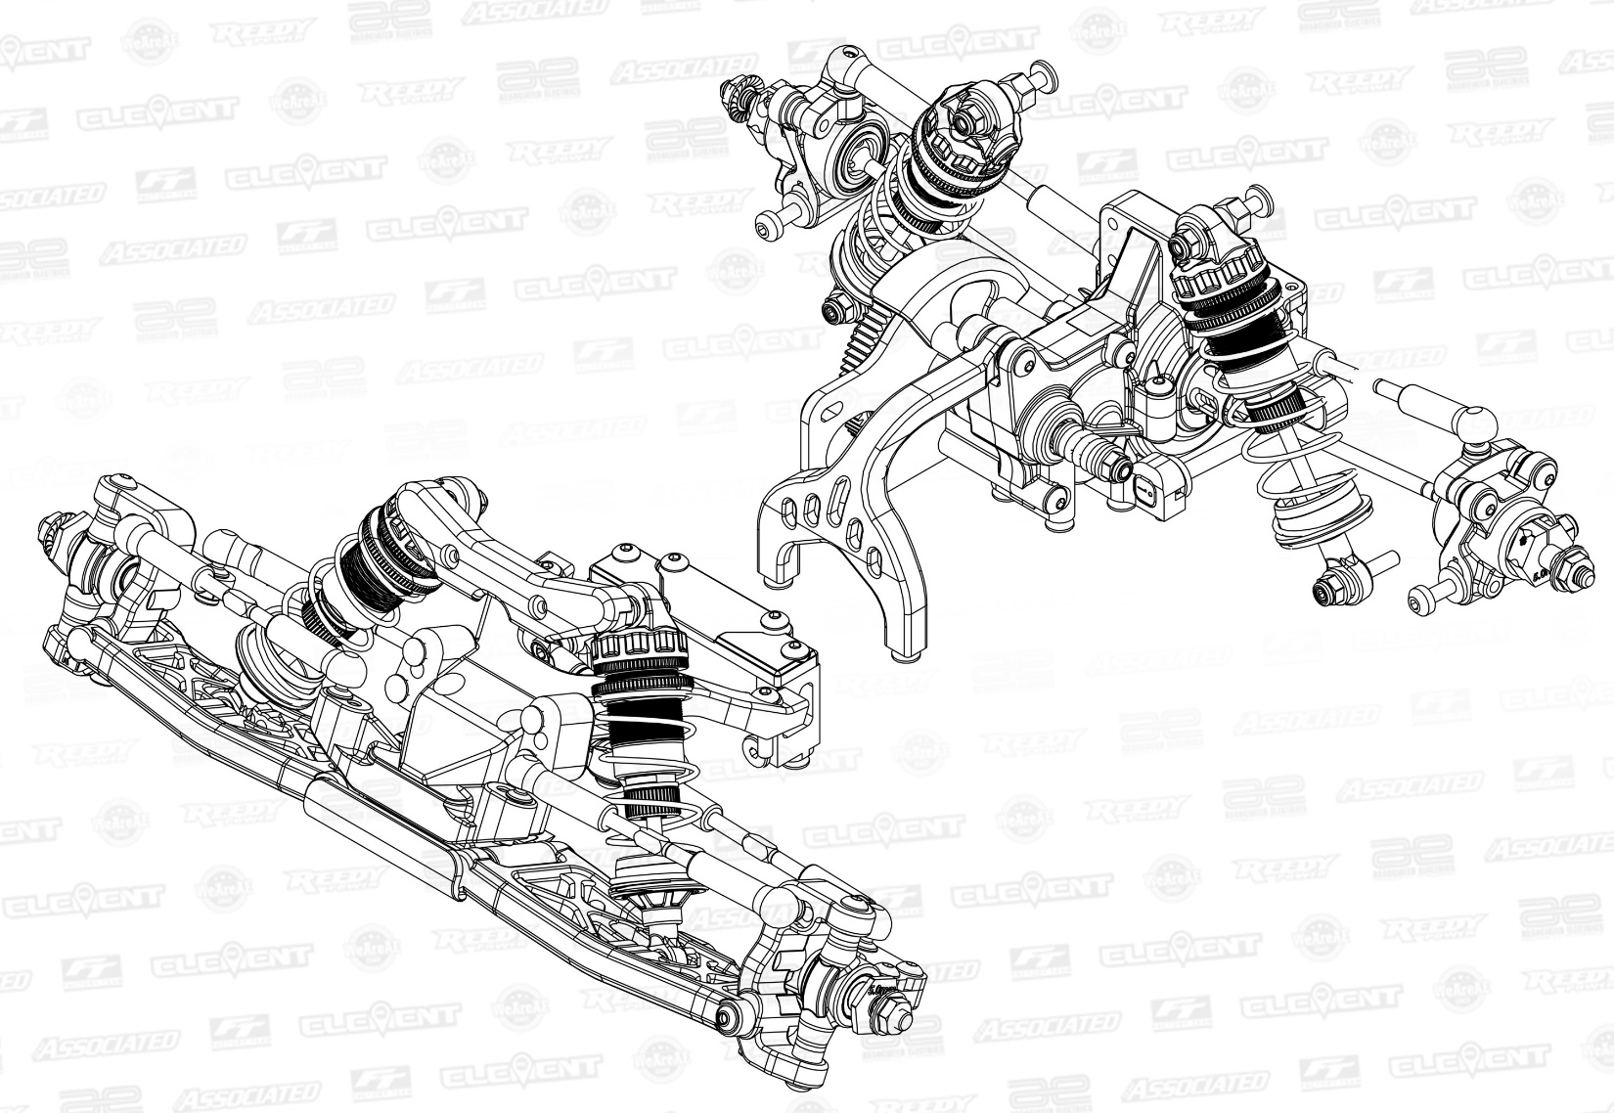

PARTS INCLUDED |  | Not Included in B6 Builder’s Kit 2
• Carbon-fiber front and rear shock towers
• Aluminum chassis and molded side rails
• Polycarbonate body and rear wing
• Rear suspension arms, rear wing mount assembly
• Front wing and front wing mount assembly
• Battery mounting strap and hardware
• Set screw and flanged nut rear arm shock mounting hardware
• Shock fluid
• Aluminum ball stud washers
• Aluminum ESC tray

REQUIRED TO COMPLETE

FEATURES

• Ball differential
• Laydown, Layback, and standup transmission cases
• 4x 13mm Big Bore shocks: 23mm shock bodies and 21mm shock shafts with X-rings
• 2x 13mm shock springs, red fronts
• 2x 13mm shock springs, orange rear
• RC10B6 front end assembly: steering, top plate, suspension, gull wing front arms and blue aluminum front axles
• 24x Factory Team precision oiled ball bearing set
• +1 carbon fiber steering arms
• 6x 48mm turnbuckles, ball cups, and HD metric ball studs
• Rear aluminum arm mounts for use with 69mm CVA bones and RC10B7 rear hubs
• Rear aluminum ball stud mount
• Aluminum one-piece top shaft
• RC10B6.3 servo mounting system with transponder mounting location
• Octalock spur gears and 19mm Octalock LCF pads
• 4x 2.5mm machined shock pistons
• Blue aluminum shock bushings
• 5mm aluminum clamping wheel hexes
• Black steel LP serrated wheel nuts
• 3mm I.D. molded plastic spacers for ball stud and shim needs
• Fasteners and metric hardware

• RC10B6 based dirt oval or drag conversion kit
• Conversion-specific body for dirt oval or drag, application
• 1:10 scale electric motor and electronic speed control
• 7.4V-7.6V 2S LiPo with “shorty” battery dimensions
• Battery charger, 2-channel surface transmitter
• 2-channel receiver and steering servo
• Spray paint for Lexan® bodies, Silicone shock fluid
• 1:10 scale wheels and tires (application specific) REQUIRED TO COMPLETE

UPC | Part No. | Description | MSRP | MAP | Pieces Per Case | Origin | Available
784695900530 | 90053 | B6 Builders Support Kit 2 | $399.99 | $269.99 | 12 | TW | End of February

OTHER HELPFUL ITEMS:
• Silicone Shock Fluid (Refer to catalog for complete listings)
• Silicone Diff Fluid (Refer to catalog for complete listings)
• Body Scissors (AE Part # 1737)
• Reamer / Hole Punch
• FT Wrench Set (AE Part #1519)
• Hobby Knife
• Needle Nose Pliers
• Wire Cutters
• Soldering Iron
• Calipers or a Precision Ruler

Download all zipped photos here: https://rc10.com/BuildersKit2Images/ (4.81 MB). Link is active for 30 days.
Please refer to our MAP Policy here: https://img2c.associatedelectrics.com/pdf/map-policy.pdf

