FOR IMMEDIATE RELEASE

August 26-30, 2025

Barcelos Buggy Arena – Barcelos, Portugal

Marcus Kaerup Wins Team Associated’s 34th IFMAR World Championship Driving the RC8B4.1e

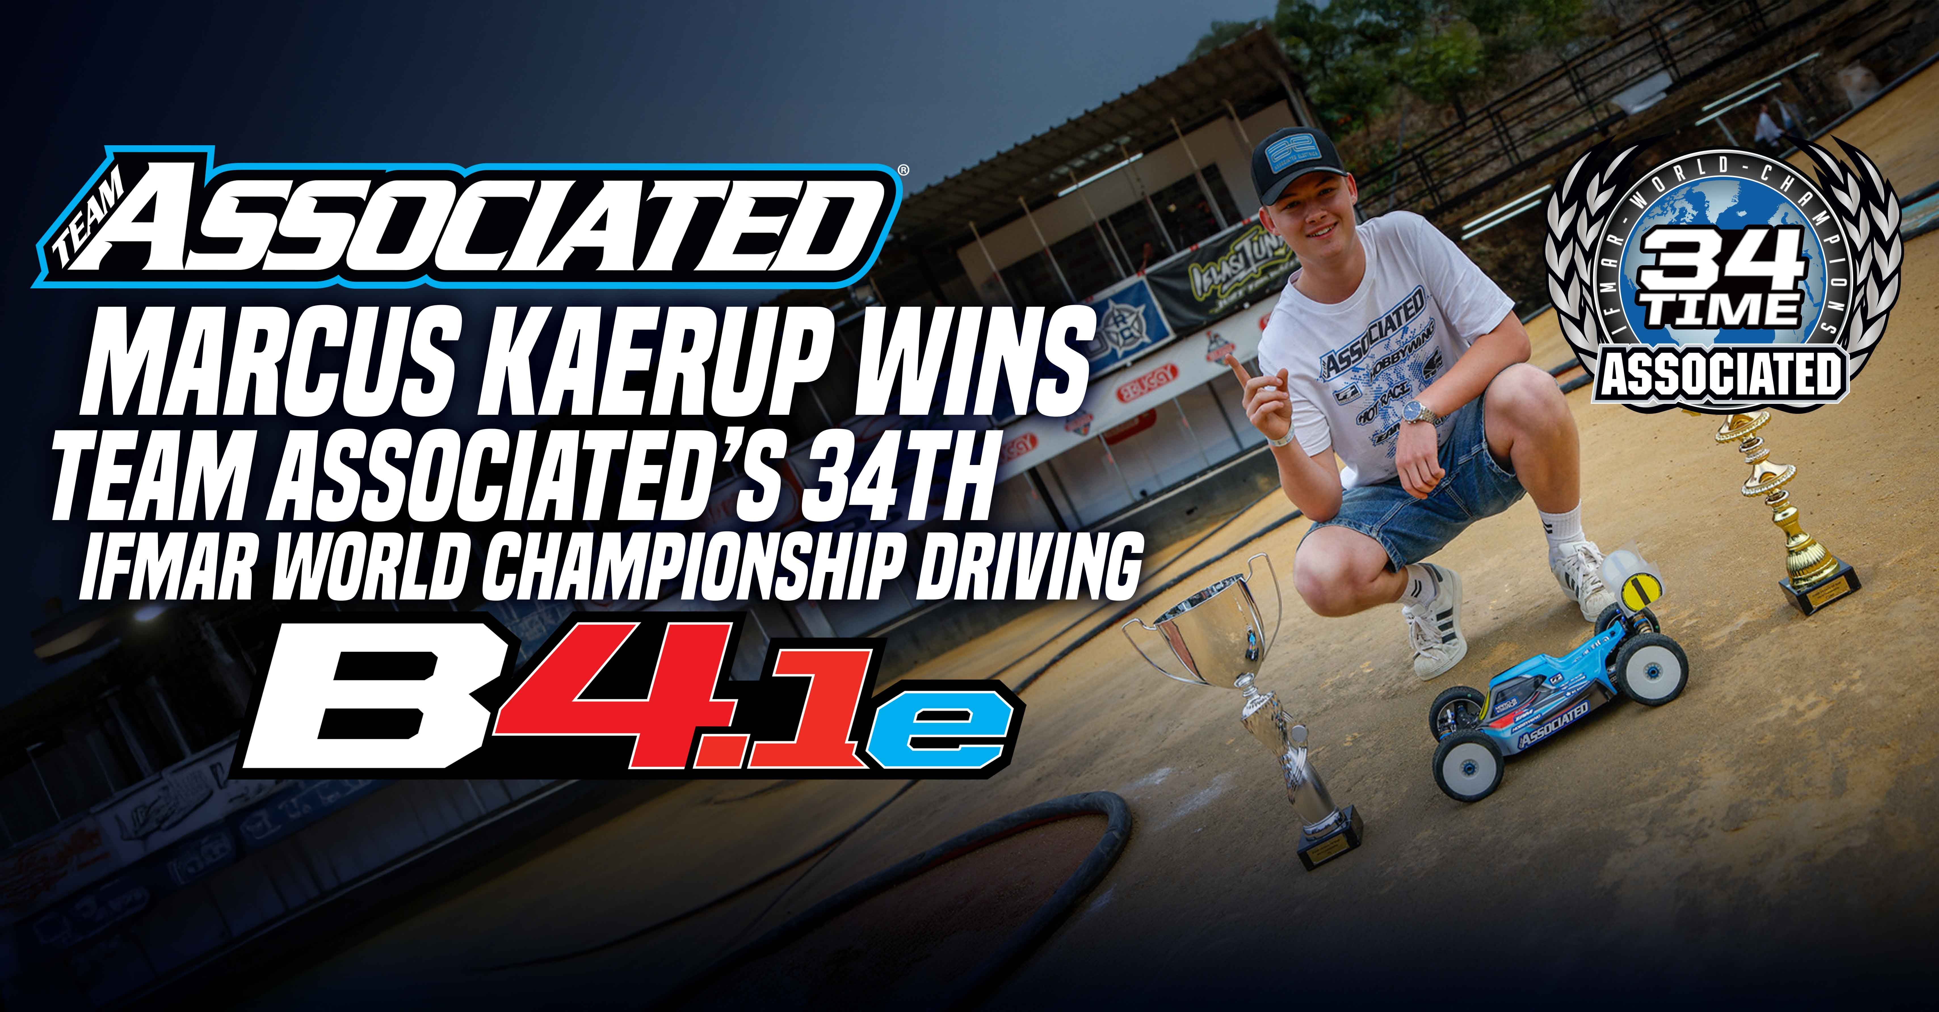

(Pictured: Marcus Kaerup with the RC8B4.1e, winning Team Associated’s 34th IFMAR World Championship)

Congratulations to Marcus Kaerup on winning Team Associated’s 34th IFMAR World Championship and the first of his young career! The 17-year-old Danish driver has been on a rocket like trajectory over the past few years and this victory sits at the top of accomplishments.

With 1:8 electric buggy growing in popularity worldwide, the IFMAR organizational body commissioned the first ever world championship for the category for 2025. Hosted by the prestigious Barcelos Buggy Arena in northern Portugal, racers from around the globe descended to the event looking to be the first ever electric 1:8 off-road buggy world champion. Fresh off hosting the EFRA Nitro Championship just months before, familiarity with the surface and track design made the event especially challenging as the weather and track conditions evolved throughout the event.

More photos on [AssociatedElectrics.com](https://www.associatedelectrics.com/news/race_results/2978-marcus-kaerup-wins-team-associatedrsquos-34th-ifmar-world-championship-driving-the-rc8b41e/)

Photos courtesy of [Circus RC](https://circusrc.com/)

Video footage courtesy of RC Racing TV – [RC Racing TV](https://youtu.be/b4E9dLMYTkk?si=rW8Ymj3CO8p5_jYk)

Not only is Marcus the first World Championship for Denmark, but he is also the first, second generation racer for Team Associated to win a World Championship.  In the early 2000’s his father, Jonas Kaerup raced for Team Associated while winning a European Championship in 2004.  With AE in his blood, Marcus represents the true meaning of WeAreAE!

Associated Electrics – **Champions By Design**.

However, the changing conditions didn’t seem to affect Kaerup’s pace.  Setting the fastest time in open practice when the grip was at it’s highest, then taking two round TQs as bumps began to form and finally securing the overall top qualifying position on a damp surface, Kaerup adapted to the changing conditions like a seasoned veteran.  Heading into the triple a-mains on Saturday, conditions changed yet again and with a practice final to feel out the track, pressure from teammate Davide Ongaro proved that no one was going to hand Kaerup the victory.

A1 began and Kaerup had pressure from second qualifier Michal Orlowski for the first half of the final, but after a small mistake from Orlowski allowed a 4 second gap to develop, Kaerup cruised to the A1 win; putting him in the driver’s seat for the title. A2 got underway and an early mistake from Orlowski allowed Davide Ongaro to slot into second place behind Kaerup. As the minutes ticked off the clock, Kaerup inched away from the 4x World Champion and with the poise of his idol, Ayrton Senna, Kaerup stayed focused on his racing lines and power delivery to cross the line in A2 as the first IFMAR 1:8 Electric Off-Road World Champion! With the title wrapped up, the remaining 12 drivers battled it out for final positions in A3 which secured 3rd and 5th overall for the Team Associated racers Davide Ongaro and Clement Boda respectively.