

**For Immediate Release:** October 2025

**New DC10 FT parts**

#72279 DC10 FT aluminum battery holder stop

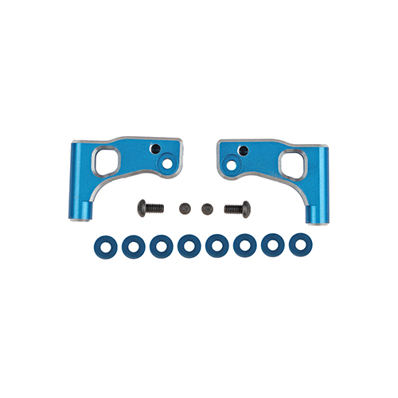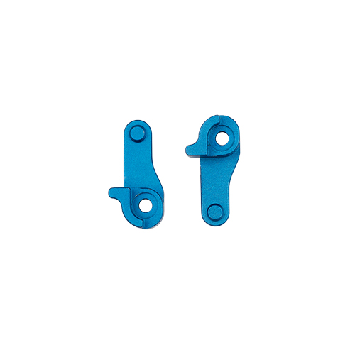#72280 DC10 FT aluminum front upper arms

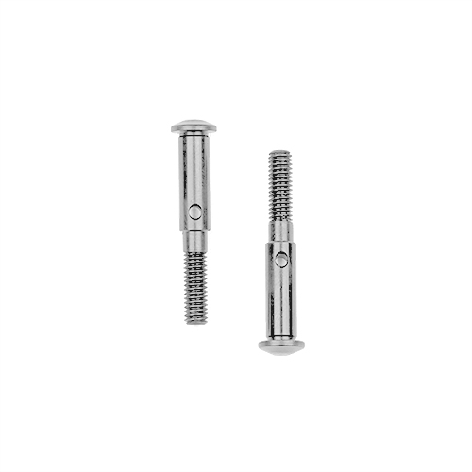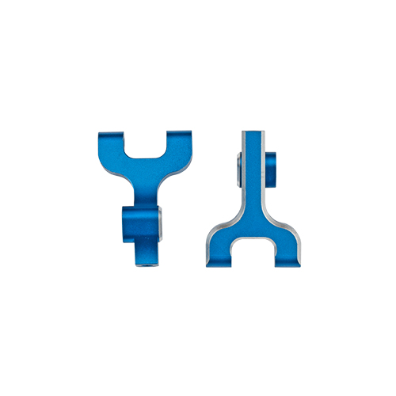#72281 DC10 FT aluminum front lower arms

#72282 DC10 FT titanium front axles

#72282

#72281

#72280

#72279

Factory Team would like to announce new parts for the DC10! These new parts include the DC10 FT aluminum battery holder stop, aluminum front upper arms, aluminum front lower arms, and titanium front axles. These parts provide a way to differentiate yourself from the crowd and hold the attention of anyone who looks at your vehicle. The aluminum battery stops, front lower arms, and front axles are a direct replacement that has the same adjustability as the stock parts while the front upper arms are narrower than the stock upper arm to allow for a greater range of caster adjustment.

**All parts compatible with:**

All DC10’s (30133C, 30133, 30134)

|  |  |  |  |  |  |  |
| --- | --- | --- | --- | --- | --- | --- |
| **UPC** | **Part No.** | **Description** | **MSRP** | **MAP** | **Origin** | **Available** |
| 784695722798 | 72279 | DC10 FT aluminum battery holder stop | $21.99 | $18.69 | CH | Now |
| 784695722804 | 72280 | DC10 FT aluminum front upper arms | $39.99 | $33.99 | CH | Now |
| 784695722811 | 72281 | DC10 FT aluminum front lower arms | $43.99 | $37.39 | CH | Now |
| 784695722828 | 72282 | DC10 FT titanium front axles | $20.99 | $17.84 | CH | Now |

Please refer to our MAP Policy here: <https://img2c.associatedelectrics.com/pdf/map-policy.pdf>

