For Immediate Release: May 2026

HD CVA BONES, 70mm #92597
HD CVA BONES, 72mm #92598
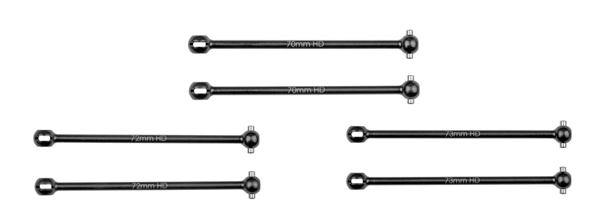
HD CVA BONES, 73mm #92599

(Pictured left to right clockwise: #92598 HD CVA Bones, 72mm, #92597 HD CVA Bones, 70mm & #92599 HD CVA Bones, 73mm)

Introducing the new HD CVA bones in 70, 72, and 73mm lengths! These bones are great for those times when the bone you are using has become too short or too long for the setup you desire. These CVA bones do not require any additional hardware to replace your current HD CVA bones.

Compatible with:
#90041/#90042/#90046/#90047/#90050/#90051

UPC | Part No. | Description | MAP | MSRP | Origin | Available
784695925977 | 92597 | HD CVA Bones, 70mm | $16.14 | $18.99 | TW | 
784695925984 | 92598 | HD CVA Bones, 72mm | $16.14 | $18.99 | TW
784695925991 | 92599 | HD CVA Bones, 73mm | $16.14 | $18.99 | TW

