

**For Immediate Release:** March 2025

**#30139** **RC10 American Custom Semitruck 6x6**

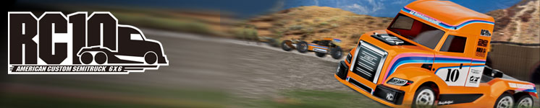

|  |
| --- |
| **ELECTRIC ■ 1:10 SCALE ■ 6 WHEEL DRIVE ■ KIT** |

**Champions by Design**

We are excited to introduce the RC10 American Custom Semitruck 6x6 Kit, a groundbreaking addition to our lineup that combines innovation with high-performance design. This comprehensive kit boasts a range of exceptional features, including durable white plastic parts, a striking new 6x6 body set, and a robust 6x6 plastic gearbox set. It also includes a 6x6 diffuser set with body accessories, a sleek gold aluminum chassis plate, and high-quality FT ball end set. For enhanced control and precision, the kit features aluminum turnbuckles, gold shock bodies, and a gold motor plate. Completing the package are satin chrome wheels, adding both style and functionality. Build the ultimate 6x6 vehicle with the RC10 American Custom Semitruck 6x6 Kit!

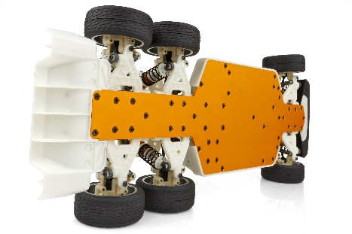

**If you’re a fan of vintage RC, then the RC10 American Custom Semitruck 6x6 Kit from Associated Electrics is the vehicle for you!**

On December 5th, 1984, the all-American designed Team Associated RC10 was introduced to the RC world. Being the first to take home the gold in both the ROAR National and IFMAR 2WD World Championships, the RC10 secured its place as a legend in RC car history. 2024 marked the 60th anniversary of Associated Electrics/Team Associated, the 40th anniversary of the RC10.

It is for that reason, we are proud to offer this unique Kit, the RC10 American Custom Semitruck 6x6.

The RC10 6x6 Kit pays tribute to the legendary RC10 by incorporating the nostalgic look of the car that changed RC off-road racing forever. The customized full decal sheet features the same classic livery along with the look of natural-colored plastics and gold anodized aluminum parts.

A TRIBUTE TO THE CAR THAT CHANGED RC OFF-ROAD RACING FOREVER!

|  |  |  |  |  |
| --- | --- | --- | --- | --- |
| **FEATURES** | |  |  | | --- | --- | | **SPECS** |  | |  |

• White color plastic parts

• New 6x6 body set

• New 6x6 plastic gearbox set

• New 6x6 diffuser set and body accessories

• New 6x6 aluminum gold chassis plate

• Factory Team ball end set

• Aluminum turnbuckle

• Gold shock body

• Gold motor plate

• Satin chrome wheel

|  |  |
| --- | --- |
| **Scale** | 1:10 |
| **Power** | Electric |
| **Length** | 465mm/18.3” * |
| **Width** | 190mm/7.48” * |
| **Weight** | Varies* |
| **Wheelbase** | 259-332mm/ 10.2”-13” |
| **Transmission Ratio** | 2.6:1 |
| **Drive** | 6WD |

|  |  |
| --- | --- |
| OTHER HELPFUL ITEMS |  |

• 1:10 scale 540-size electric RC car motor

• 1:10 scale radio control electronic speed control

• 7.4V-7.6V 2S LiPo with "shorty" battery dimensions

(standard or low-profile height)

• Battery charger (for one of the batteries mentioned above)

• 2 channel surface transmitter, 2 channel receiver, and steering servo

• Lexan specific spray paint for body

• 1:10 scale off-road wheels and tires

• 4 AA batteries for radio-controlled car radio

• Other helpful items: Silicone Shock Fluid, Silicone Diff Fluid, Body Scissors (#1737), Reamer (#1499) or Hole Punch, FT Wrench Set (#1519), Hobby Knife, Needle Nose Pliers, Wire Cutters, Soldering Iron, Calipers or a Precision Ruler.

|  |
| --- |
| **CATALOG INFORMATION** |

|  |  |  |  |  |  |  |  |
| --- | --- | --- | --- | --- | --- | --- | --- |
| **UPC** | **Part No.** | **Description** | **MSRP** | **MAP** | **Pieces Per Case** | **Origin** | **Available** |
| 784695301399 | 30139 | RC10 American Custom Semitruck 6x6 Kit | $559.99 | $379.99 | 4 | TW | April |

Download all zipped photos here: <https://rc10.com/RC106X6SEMIIMAGES/> (1.6MB). Link is active for 30 days.

